Philips Xperion 6000 LED Under Hood Work Light Give Pros Intense, Hands-Free Lighting

Advanced features help make mechanics more productive in the shop bay

Las Vegas, NV, October 31, 2023 – Lumileds, a leading lighting solutions company for the automotive industry, offers the Philips Xperion 6000 Under Hood LED Work Light, designed to help make auto service professionals more productive. This advanced LED work light features a motion detection switch that allows mechanics to turn the light on and off with a wave of their hand, so they can operate it without putting down tools or interrupting their work. Built with a telescoping mount that allows the light to be fitted under most any vehicle hood, the Xperion 6000 Under Hood LED Work Light provides up to 1200 lumens and a 5800K color temperature so that technicians can see clearly to work quickly and accurately. A 120° wide angle beam illuminates the entire engine compartment, and a user-selectable dimming function give users the right amount of light, where and when they need it.

Designed with 32 high intensity LEDs, the Xperion 6000 Under Hood LED Work Light provides up to three hours run time in the 1200 lumens boost mode and up to 20 hours run time in the 120 lumens eco mode. The light is IP54 rated for resistance to dust and water and IK07 rated for resistance to impacts. The grip surfaces are ABS rubber, and retain excellent grip even when exposed to grease and oils. The light’s rechargeable lithium battery can be fully charged in under five hours.

“We know that in a very literal way, time is money for professional service technicians,” notes Jason Dreger, Lumileds Product Manager. “Anything we can do to help them save a few seconds here and there is appreciated. The hands-free operation of the Xperion 6000 Under Hood LED Work Light does just that. Professional technicians depend on the functionality, quality, and reliability of their tools and all of our new work lights ensure that they have a light that is durable, dependable, and simple to use.”

For more information, contact: philipsautoorders@lumileds.com or call 1-866-254-6989.

About Lumileds
Lumileds is a global leader in OEM and aftermarket automotive lighting and accessories, camera flash for mobile devices, MicroLED, and light sources for general illumination, horticulture, and human-centric lighting. Our approximately 6,000 employees operate in over 30 countries and partner with our customers to deliver never before possible solutions for lighting, safety, and well-being. To learn more about our company and solution portfolios, please visit https://lumileds.com.

As a leading lighting solutions company for the automotive industry, Lumileds is licensed to use the Philips brand for its automotive lighting and accessories product portfolio.

Image files:
Philips Xperion 6000 Under Hood LED Work Light.jpg

Captions:
The Philips Xperion 6000 Under Hood LED Work Light is designed to help make auto service professionals more productive.

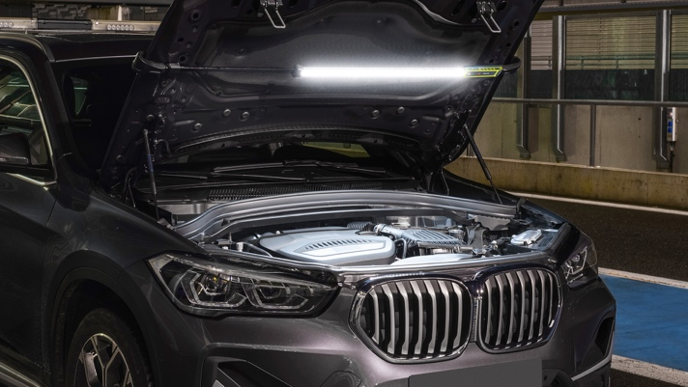

For further information, please contact:
Aubry Baugh, MBA
Sr. Manager, Aftermarket Marketing Leader, NA
Lumileds
34119 W. 12 Mile Rd., Suite 102
Farmington Hills, MI 48331
Tel: (248) 699-2232
Email: aubry.baugh@lumileds.com

Media Contact:
Jake Spencer
Barolin + Spencer
800-536-6222
jake.spencer@barolin-spencer.com

299-23/PL4725

