New Philips Xperion 3000 LED Work Lights Provide Durable, Versatile, and Long Lasting Illumination at Affordable Price

New line includes seven hand-held lights, two flood lights, headband headlamp.

Las Vegas, NV October 31, 2023– Lumileds, a leading lighting solutions company for the automotive industry, has just introduced the new line of Philips Xperion 3000 LED work lights. Designed for durability, reliability, and affordability, Xperion 3000 LED work lights include advanced features that make the lights more useful to DIYers and auto service professionals alike.

Xperion 3000 lights are IP rated for resistance to impact, water, and dust. Their grip surfaces retain excellent grip even in the presence of grease and oils. Many of the Xperion 3000 work lights are equipped with integrated magnets and 360° rotating hooks, leaving hands free for the job.

The Xperion 3000 LED line includes 10 work lights, nine of which are powered by rechargeable lithium batteries. The Xperion 3000 Pen eco is powered by three AAA batteries. The “Pillar” hand-held work light includes a powerful main work light as well as a spotlight. The Xperion 3000 “Slim” is a hand-held light that features a folding light panel with main and spotlight illumination. The Xperion 3000 “Zoom” resembles a flashlight, but features a tilting light with variable zoom focus and powerful magnetic mounting. The Xperion 3000 “Line” is a full-size professional style inspection light with hook and magnet mounting options. The Xperion 3000 “Pocket” is a palm-sized lamp with two output modes and a folding hang hook. The Xperion 3000 “Headlamp” is a wearable headband work light with two light sources and three output modes. The Xperion 3000 “Flood” is a small but powerful projector work light with three output modes. It can also be used as a power bank to run other devices. The Xperion 3000 “Penlight” combines a broad inspection light and a handy spotlight for tight spaces.

According to Aubry Baugh, Senior Manager, Aftermarket Marketing Leader, NA, “Our new Philips Xperion 3000 LED work lights provide professional quality and lighting performance at price points that most any DIYer can afford. We anticipate strong demand for the lights as they represent an excellent combination of value, quality, and performance.”

For more information, email: philipsautoorders@lumileds.com or call 1-866-254-6989.

About Lumileds
Lumileds is a global leader in OEM and aftermarket automotive lighting and accessories, camera flash for mobile devices, MicroLED, and light sources for general illumination, horticulture, and human-centric lighting. Our approximately 6,000 employees operate in over 30 countries and partner with our customers to deliver never before possible solutions for lighting, safety, and well-being. To learn more about our company and solution portfolios, please visit https://lumileds.com.

As a leading lighting solutions company for the automotive industry, Lumileds is licensed to use the Philips brand for its automotive lighting and accessories product portfolio.

For further information, please contact:
Aubry Baugh
Senior Manager, Aftermarket Marketing Leader, NA
Lumileds
34119 W. 12 Mile Rd., Suite 102
Farmington Hills, MI 48331
Tel: (248) 699-2202
Email: aubry.baugh@lumileds.com

Media Contact:
Jake Spencer
Barolin + Spencer
800-536-6222
jake.spencer@barolin-spencer.com

Image file:
Philips_Xperion_3000_range.jpg

Caption:

New Philips Xperion 3000 LED work lights combine quality and affordability.

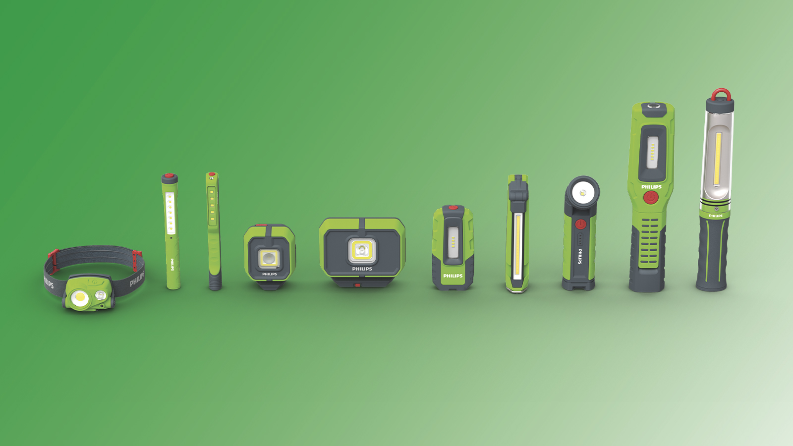

308-23/PL4725

