Lumileds Adds LED Pod Lights to Philips Ultinon Drive 5000 Series of Off-Road Auxiliary Lighting

Las Vegas, NV October 31, 2023– Lumileds, a leading lighting solutions company, has added to the Philips Ultinon Drive 5000 Series of LED auxiliary lighting with five new LED pod lights. The new lights include a 3” cube spotlight, a 3” driving light, and a 3” flood light, as well as a 4” round flood light and a 7” round light with a combination driving/flood beam pattern. All the new Ultinon Drive LED Pod Lights feature LED heat sinks, stainless steel brackets, and Lexan® light covers.
Off-road ready
Philips Ultinon Drive LED Pod Lights have been engineered to provide reliable, brilliant lighting in the conditions that dedicated off-roaders often encounter. They are constructed with 6063 aluminum one-piece bodies and are rated IK07 for resistance to impacts and IP68/IP69K for resistance to water and dust intrusion. Stainless-steel brackets provide extreme resistance to weather, salt, and impacts, and available heavy-duty automotive-grade wire harnesses feature DT connectors for fast installation and superior water resistance.
State-of-the art optics and electronics
Philips Ultinon Drive LED Pod Lights feature state-of-the-art optical packages. High powered LEDs combine with custom tuned optics to enable these LED pod lights to exceed drivers’ expectations. The Lexan® light covers protect the high output LEDs, provide excellent resistance to impacts and scratches, and won’t yellow or haze over time. The pod lights’ electronics feature intelligent temperature control and reverse polarity protection. In addition, they don’t create electrical interference that can affect vehicle functions.

According to Jason Dreger, Product Marketing Manager, Automotive Aftermarket Accessories for Lumileds, “Our original introduction of the Philips Ultinon Drive 5000 Series of LED lightbars has been a tremendous success. These new LED pod lights give off-roaders more beam choices, allowing them to customize their lighting to meet their driving needs. They can be mounted in many different places on the vehicle and can be aimed wherever the light is needed. We expect that, like our Ultinon Drive lightbars, they will be very well received by the off-road community.”

The Ultinon Drive 5000 Series of LED auxiliary lighting now includes eight LED lightbars and five LED Pod lights, all built for demanding conditions and rugged off-road adventures.

For more information, email: philipsautomotivemarketing@lumileds.com

About Lumileds
Lumileds is a global leader in OEM and aftermarket automotive lighting and accessories, camera flash for mobile devices, MicroLED, and light sources for general illumination, horticulture, and human-centric lighting. Our approximately 6,000 employees operate in over 30 countries and partner with our customers to deliver never before possible solutions for lighting, safety, and well-being. To learn more about our company and solution portfolios, please visit https://lumileds.com .

As a leading lighting solutions company for the automotive industry, Lumileds is licensed to use the Philips brand for its automotive lighting and accessories product portfolio.

For further information, please contact:
Aubry Baugh, MBA
Sr. Manager, Aftermarket Marketing Leader, NA
Lumileds
34119 W. 12 Mile Rd., Suite 102
Farmington Hills, MI 48331
Tel: (248) 699-2232
Email: aubry.baugh@lumileds.com

Media Contact:
Jake Spencer
Barolin + Spencer
800-536-6222
jake.spencer@barolin-spencer.com

Image files:
Ultinon Drive Pod Lights.jpg

Ultinon Drive Pod Light in use.jpg

Caption:
Philips Ultinon Drive 5000 Series of LED Pod Lights includes five models.

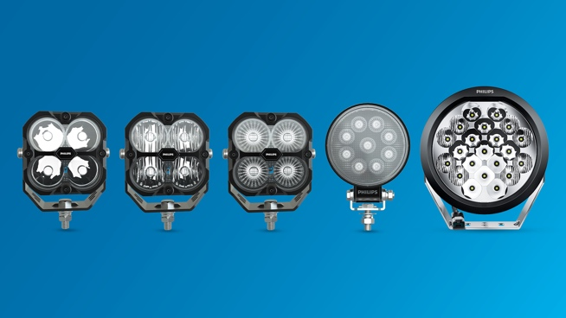

294-23/ PL4734

