Philips Xperion 6000 LED Flood and Flood Mini Work Lights Designed to Save Time for Service Pros

Two-part magnetic handles make it easy to aim the light exactly where it’s needed.

Las Vegas, NV – October 31, 2023 – Lumileds, a leading lighting solutions company for the automotive industry, offers Philips Xperion 6000 LED Flood Lights, designed to help service technicians light up their work area faster and more precisely. The Xperion 6000 LED Flood and Flood Mini feature pivoting handles with powerful magnets embedded in them, allowing users to mount the Xperion 6000 LED flood lights on most any metallic surface. In addition, the handles are formed from two halves that can be rotated apart to create hooks that can be used to hang the lights. These options make it easy for technicians to quickly aim the light where they need it to get their job done. Both the Flood Audio and Flood mini feature ABS rubber grip surfaces that maintain excellent grip even when covered with oil or grease.

The Philips Xperion 6000 Flood Audio features a variable beam that delivers 1000 lumens in flood mode, and 250 lumens in spotlight mode. The light includes built-in Bluetooth speakers that allow audio to be played directly through the work light, and also serves as a USB power bank. The Flood Audio features a motion detection function and a smart-zoom knob that allows users to easily control the light, even while wearing work gloves. The light can be fully charged within 5 hours via USB-C cable, and it features a battery life LCD display. Battery life is rated at up to 9.0 hours in spotlight mode. The Flood Audio is rated IP65 for water resistance and IK07 for resistance to impacts.

The Philips Xperion 6000 Flood Mini was specifically designed for illuminating work in tight spaces, and it fits comfortably in the hand. A glove-friendly smart-zoom knob controls the light’s variable projector function. Flood Mini features two output options; 500 lumens in flood mode to 100 lumens in spotlight mode. Battery life is rated at up to 5.0 hours in spotlight mode. The Flood Mini is rated IP55 and IK07.

“We wanted to make it easier for technicians to get the light they need, where they need it.” notes Jason Dreger, Lumileds Product Manager. “Our goal was to make the Xperion 6000 Flood Lights as easy as possible to set up and use, so that techs can get back to the work they need to do.”

For more information, email: philipsautomotivemarketing@lumileds.com

About Lumileds
Lumileds is a global leader in OEM and aftermarket automotive lighting and accessories, camera flash for mobile devices, MicroLED, and light sources for general illumination, horticulture, and human-centric lighting. Our approximately 6,000 employees operate in over 30 countries and partner with our customers to deliver never before possible solutions for lighting, safety, and well-being. To learn more about our company and solution portfolios, please visit https://lumileds.com.

As a leading lighting solutions company for the automotive industry, Lumileds is licensed to use the Philips brand for its automotive lighting and accessories product portfolio.

For further information, please contact:
Aubry Baugh, MBA
Aftermarket Regional Marketing Leader, North America
Lumileds
34119 W. 12 Mile Rd., Suite 102
Farmington Hills, MI 48331
Tel: (248) 699-2232
Email: aubry.baugh@lumileds.com

Media Contact:
Jake Spencer
Barolin + Spencer
800-536-6222
jake.spencer@barolin-spencer.com

Image file:

Philips-Xperion-Flood-Audio-Mini.jpg

Caption:

Philips Xperion 6000 Flood Lights make it easier to aim the beam where it’s needed.

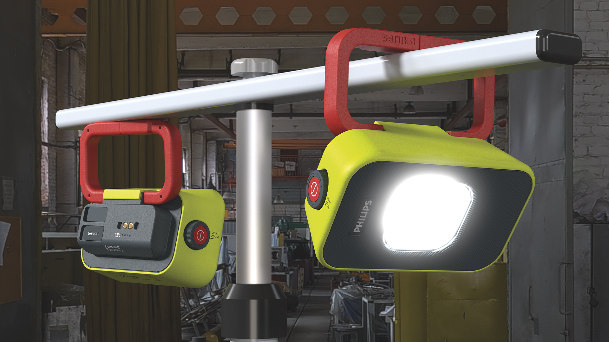

Image file:

Philips-Xperion-Flood-Audio.jpg

Caption:

Philips Xperion 6000 Flood Lights make it easier to aim the beam where it’s needed.

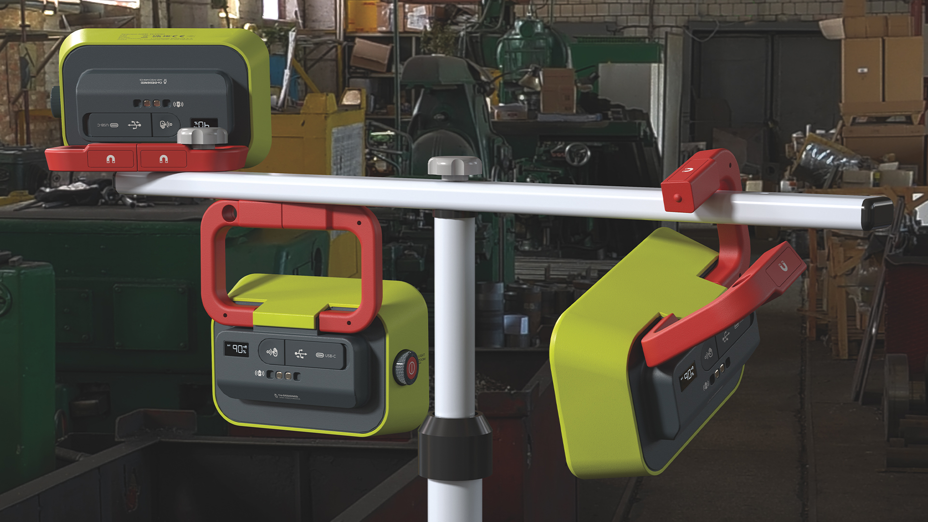

299-22/ PL4732

