CRC® NEWS RELEASE
Text-to-Reorder Reminders Now Available for CRC SmartWasher® Bioremediating Parts Washer Users
Free service helps ensure users maintain optimum parts cleaning capability

Las Vegas, NV – CRC Industries has introduced a free text service for CRC SmartWasher® users that reminds them when to reorder OzzyMat® Multi-Layer Fluid Activation Mats for their SmartWasher. The text reminders are set by the user and continue automatically, every 30 days.

The OzzyMat is one of three parts that make CRC SmartWasher Bioremediating Parts Washing Systems effective, efficient, and less expensive to operate than traditional solvent-based parts washers. Along with the CRC SmartWasher Parts Washer and the powerful OzzyJuice® Degreasing Solution, the system includes the OzzyMat that's infused with a proprietary blend of oil-eating microbes. These naturally occurring microorganisms break down and convert oil, grease, and carbon-based contaminants into water and CO₂.

This process of bioremediation makes the CRC SmartWasher a self-cleaning system and allows the OzzyJuice Degreasing Solution to be used over and over again. Shops that use the CRC SmartWasher Parts Washer don’t have to periodically pay for new solvent, and they don’t pay to have contaminated solvent hauled away for treatment.

According to Tina Christie, SmartWasher Product Manager for CRC Industries, Inc., “We introduced this new free text service to help make sure that our SmartWasher users are getting the maximum cleaning power from their washers. Because you can use OzzyJuice over and over again, we suspected that people would sometimes forget to change out their OzzyMat. Users can go to smartwasher.com and set up a free reminder. Once set, they’ll get an SMS message every month reminding them to order new mats if needed.”

The EPA continues to increase restrictions on the use of solvents found in traditional parts washers. However, all CRC SmartWasher Parts Washers, including the BenchtopPRO®, are compliant for use in all 50 states, because they use no solvents or other VOCs.

For more information about CRC Industries, visit www.crcindustries.com or follow the CRC brand on Facebook, Twitter, LinkedIn, TikTok and Instagram.

About CRC
CRC Industries, Inc. is a global leader in the production of specialty products and formulations for the do-it-yourselfer and maintenance professional, serving the automotive, industrial, electrical, marine, heavy truck, hardware, and aviation markets. CRC trademarked brands include: CRC®, Brakleen®, Evapo-Rust®, K&W®, Marykate®, SmartWasher®, Sta-Lube®, and Weld-Aid®.
Media Contact:
Raquel Wenger
Director of Marketing, Americas
CRC Industries, Inc.
Horsham, PA 19044
215-674-4300
raquel.wenger@crcind.com

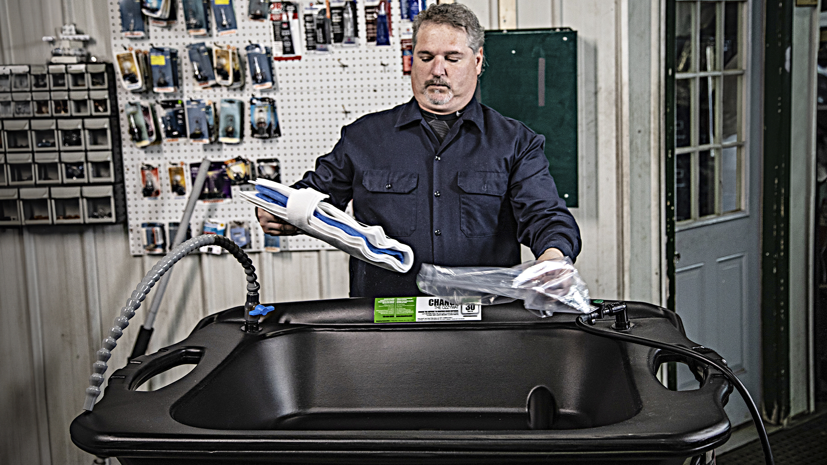

Image:
CRC SmartWasher text to reorder.jpg

Caption:
Text-to-Reorder reminders are now available for CRC SmartWasher® users

299-23/CC402

