CRC® NEWS RELEASE
CRC Industries Sponsors TechForce Foundation to Support Next Generation of Technicians
CRC commissioned Clay Millican and Jeff Lutz of Street Outlaws to upgrade a 2006 Pontiac GTO that will be raffled to support the Foundation

Las Vegas, NV – CRC Industries has launched a new “CRC Build for the Future” scholarship program in cooperation with the TechForce Foundation, a nonprofit organization that supports young technicians. The program will help young men and women who wish to pursue careers in the trades by providing financial assistance for their technical school education. The CRC Build for the Future scholarship will financially assist at least 10 students in pursuit of an education in technical school. Five scholarships will be awarded for automotive education and five for industrial/welding. At least three of the scholarships will be awarded to women.

To help raise funds and awareness for the scholarship program, CRC partnered with drag racer, Clay Millican, and Jeff Lutz of the popular TV show, Street Outlaws, to build a custom GTO that will be actioned by MECUM Auto Auction. CRC will donate the proceeds of the auction to TechForce to fund the 10 scholarships. CRC guarantees that each student will receive a minimum of $2,500, and up to a maximum of $8,000 each, depending on the value of auction sale. If auction proceeds exceed $80,000, 100% of the excess will be donated to TechForce to award as additional scholarships of up to $8,000 each.

According to TechForce CEO, Jennifer Mahar, “We’re thrilled to partner with CRC Industries on this initiative. We share the same mission of helping young people find rewarding careers in the trades. We’re tremendously grateful for CRC’s financial support and the time and effort their team has put into helping to make the TechForce Foundation scholarship program a success.”

To apply for the CRC sponsored scholarship, applicants can register through the TechForce portal at https://techforce.org/app/sign-up. By joining the TechForce Network, applicants will have access to many other scholarships offered through TechForce in addition to the CRC scholarship.

“We believe that investing in the success of our next generation of technicians is vital to the long-term sustainability of the trades, including the automotive aftermarket,” notes Raquel Wenger, CRC Director of Marketing, Americas. “That’s why we commissioned NHRA World Champion Drag Racer, Clay Millican, and his partner Jeff Lutz to modify and upgrade a perfectly preserved 2006 Pontiac GTO. The GTO will be revealed at our 2023 SEMA booth and then go on tour in early 2024. In May of 2024, it will be auctioned to the highest bidder at the Indy MECUM Auto Auction, with the proceeds going to TechForce.”

For more information about the GTO build and CRC Build for the Future scholarship, visit crcbuildforthefuture.com. To learn more about CRC Industries, visit www.crcindustries.com or follow the CRC brand on Facebook, Twitter, LinkedIn, TikTok and Instagram.

About CRC
CRC Industries, Inc. is a global leader in the production of specialty products and formulations for the do-it-yourselfer and maintenance professional, serving the automotive, industrial, electrical, marine, heavy truck, hardware, and aviation markets. CRC trademarked brands include: CRC®, Brakleen®, Evapo-Rust®, K&W®, Marykate®, SmartWasher®, Sta-Lube®, and Weld-Aid®.
Media Contact:
Raquel Wenger
Director of Marketing, Americas
CRC Industries, Inc.
Horsham, PA 19044
215-674-4300
raquel.wenger@crcind.com

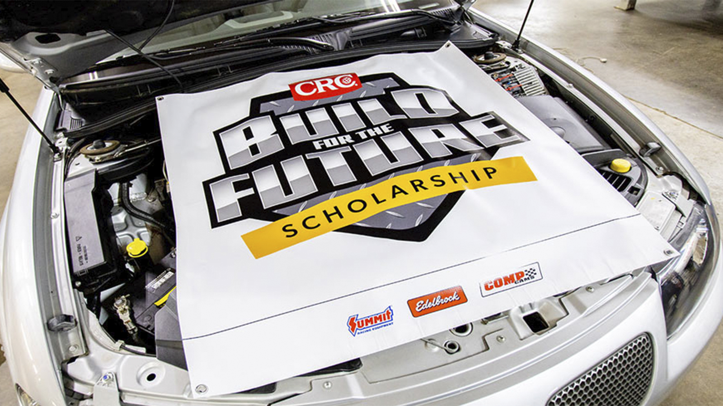

Build for the Future Scholarship.jpg

299-23/CC402

