CRC® NEWS RELEASE
Updated CRC® GDI Service Pack Delivers 40% More Carbon Deposit Cleaning Power
Pack now removes up to 68% of intake valve carbon deposits in one pass

Las Vegas, NV – CRC Industries has just introduced an improved version of the CRC GDI Service Pack that provides 40% more carbon deposit cleaning power than the previous version. The cleaning power gains come from a newly reformulated version of the CRC GDI IVD® Intake Valve and Turbo Cleaner. The reformulated cleaner now removes up to 68% of carbon deposits in one application, as opposed to the previous formula’s 46%.

The CRC GDI Service Pack includes the CRC GDI IVD Intake Valve and Turbo Cleaner, CRC Mass Air Flow Sensor Cleaner, CRC Throttle Body and Air-Intake Cleaner, and CRC 1 Tank Power Renew®. All products in the Service Pack are also available individually. Combined, the products in the Pack help clean and optimize the performance of MAF sensors, throttle bodies, intake valves, fuel injectors, spark plugs, and combustion chambers.

Before the invention of CRC GDI IVD Intake Valve & Turbo Cleaner, cleaning GDI intake valves was a costly, labor-intensive process, requiring engine disassembly to manually clean the valves or walnut-shell blasting. With the new CRC GDI Service Pack, this service can be performed up to 75% faster than previous methods and without engine teardown, saving hundreds of dollars for consumers.

According to John Rarick, Senior Product Manager, CRC Industries, Inc., “Our CRC GDI Service Pack was already a market-leading solution for cleaning GDI carbon deposits and optimizing vehicle performance. Now, with the more powerful formula for our CRC GDI IVD Intake Valve and Turbo Cleaner, we have an even more appealing product for pros and DIYers alike.”

CRC has produced a demonstration video for the CRC GDI Service Pack featuring Emily Reeves of Flying Sparks Garage. It can be viewed by visiting: https://www.youtube.com/watch?v=TAmhld2vujU&t=1s

For more information about CRC Industries, visit www.crcindustries.com or follow the CRC brand on Facebook, Twitter, LinkedIn, TikTok and Instagram.

About CRC
CRC Industries, Inc. is a global leader in the production of specialty products and formulations for the do-it-yourselfer and maintenance professional, serving the automotive, industrial, electrical, marine, heavy truck, hardware, and aviation markets. CRC trademarked brands include: CRC®, Brakleen®, Evapo-Rust®, K&W®, Marykate®, SmartWasher®, Sta-Lube®, and Weld-Aid®.
Media Contact:
Raquel Wenger
Director of Marketing, Americas
CRC Industries, Inc.
Horsham, PA 19044
215-674-4300
raquel.wenger@crcind.com

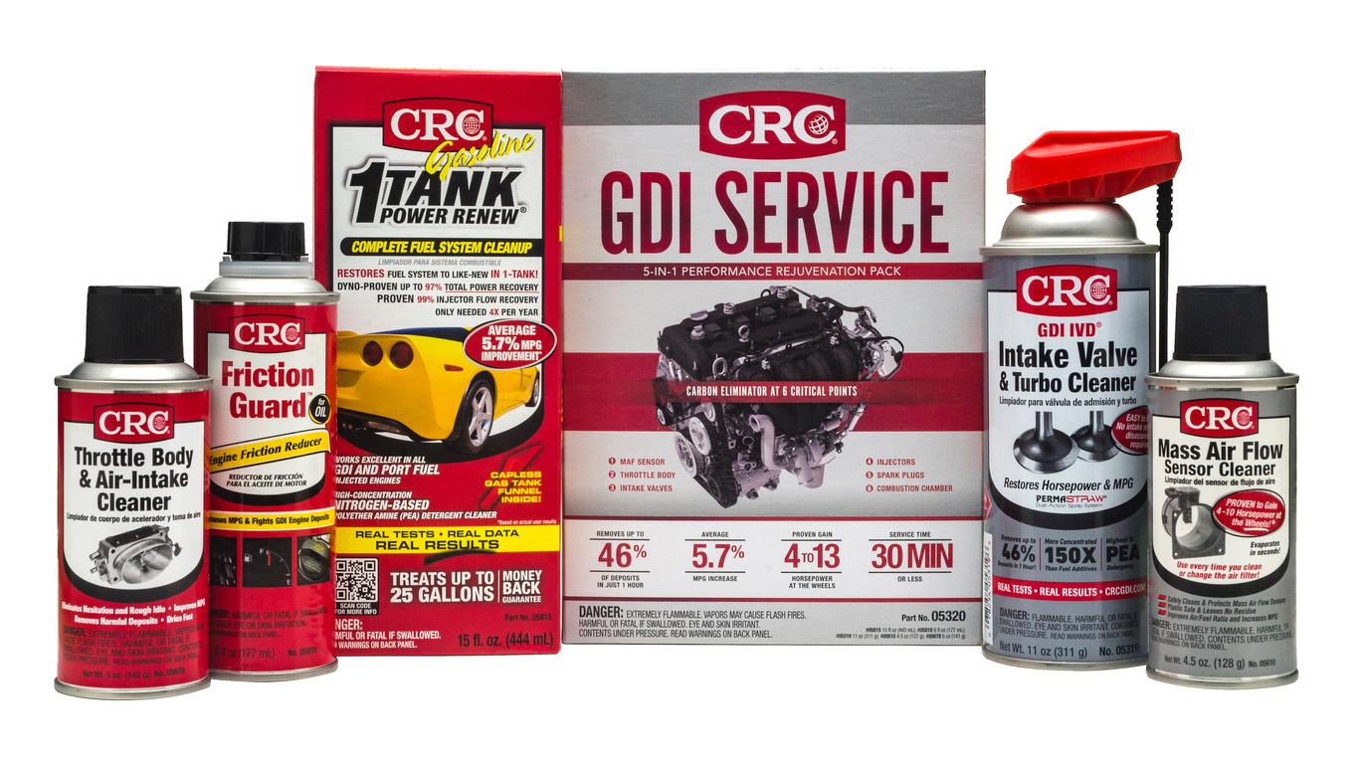
Image:
CRC GDI Service Pack.jpg
Caption:
CRC GDI Service Pack now has 40% more carbon deposit cleaning power

299-23/CC402

