CRC® NEWS RELEASE
CRC Industries Expands Evapo-Rust® Line with New One-Quart Canister
Built-in dip basket enables rust removal right in the retail container

Horsham, PA – CRC Industries has introduced a new one-quart canister size for its innovative Evapo-Rust® brand of rust remover that will hit retail shelves in February, 2024. A dip basket has been integrated into the canister, so users don’t have to pour the product out into a separate container – they can remove rust right in the canister. The one quart size is ideal for small tools, nuts and bolts, garden tools, and other jobs around the garage and home.

CRC Evapo-Rust is a non-corrosive rust remover dip that removes rust to bare metal without sanding or scrubbing. It is simple and easy to use, with no need for mixing. Evapo-Rust comes ready to use – just soak the rusted items and rinse with water when done. The Evapo-Rust solution can be used over and over again, and it will not harm paint.

“Our new one-quart canister is our most convenient offering yet, providing an all-in-one container for usage and storage,” notes Jonah Rauch, Evapo-Rust Product Manager at CRC, Americas. “We saw the need for a size that would be well-suited to home use and small jobs in the workplace. The dip basket is a real bonus – it makes using Evapo-Rust a breeze for anyone.”

The CRC Evapo-Rust brand consists of several rust removal and prevention products including Evapo-Rust®, Rust-Block™, ThermoCure™, and Evapo-Rust® Gel. These products were developed and are produced in the U.S., and they are sold in 48 countries and over 40,000 retail stores. Evapo-Rust products are used by the U.S. military and leading industrial companies to safely remove rust from metallic components. The brand was previously named a winner of R&D Magazine’s ‘Top 100 Inventions of the Year’ award.

For more information about CRC Evapo-Rust, visit evapo-rust.com. For more information about CRC Industries, visit www.crcindustries.com or follow the CRC brand on Facebook, Twitter, LinkedIn, TikTok and Instagram.

About CRC
CRC Industries, Inc. is a global leader in the production of specialty products and formulations for the do-it-yourselfer and maintenance professional, serving the automotive, industrial, electrical, marine, heavy truck, hardware, and aviation markets. CRC trademarked brands include: CRC®, Brakleen®, Evapo-Rust®, K&W®, Marykate®, SmartWasher®, Sta-Lube®, and Weld-Aid®.
Media Contact:
Raquel Wenger
Director of Marketing, Americas
CRC Industries, Inc.
Horsham, PA 19044
215-674-4300
raquel.wenger@crcind.com

Image name:
Evapo-Rust 1-quart canister.jpg
Caption:
The new CRC Evapo-Rust® 1-quart canister features an integrated dip basket.

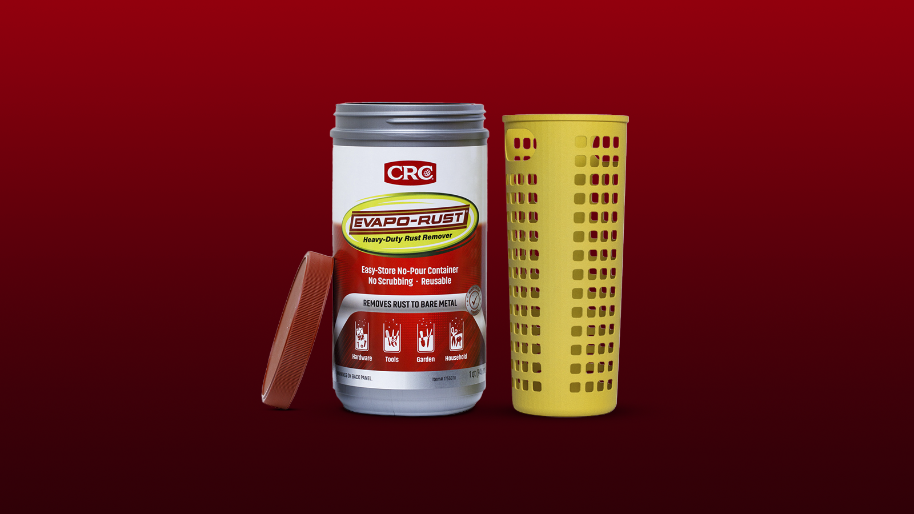

299-22/CC402

