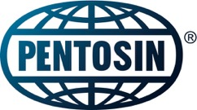
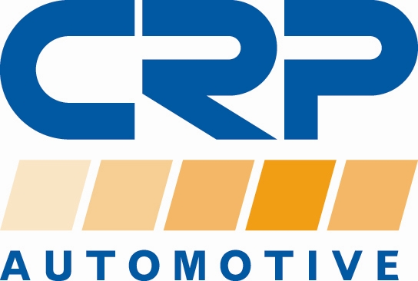

PRESS RELEASE

For additional information contact:
Monika LaPrete, Marketing Communications Director
Phone: (609) 578.4100 Fax: (609) 578.4050
E-mail: Mlaprete@crpindustries.com

New Pentosin FFL-8 Transmission Fluid OE Approved for Porsche Panamera and Taycan Models

- Only approved first-fill solution provides optimized friction properties, best load carrying capacity

Cranbury, NJ… CRP Automotive (crpautomotive.com), a leading source of OE-quality replacement and service parts, has launched a new transmission fluid for vehicles with ZF/Porsche Double Clutch Transmissions. Pentosin FFL-8 Transmission Fluid is the only approved first-fill Double Clutch Transmission Fluid (DCTF) for the ZF/Porsche Double Clutch Transmission that utilize a wet clutch.

Pentosin FFL-8 fluid provides coverage for Porsche Panamera model years 2017 and up and is the only first-fill axle fluid for the Porsche Taycan model years 2020 and newer. The fluid provides optimized friction properties and excellent load carrying capacity, even under harsh driving conditions and throughout the extended lifetime of the vehicle.

A fully synthetic fluid, Pentosin FFL-8 is formulated with anti-wear chemistry and friction modifiers that help to achieve stable friction performance in modern transmissions.

CRP Automotive offers Pentosin FFL-8 in 1-liter (P/N 1090107), 5-liter (P/N 1090207), and 20-liter (P/N 1090208) sizes. Application coverage includes over 40,000 VIO in the United States and Canada.

Jumpstart Team Sign up
Join CRP Automotive’s Jumpstart Team. It’s the best way to stay up to date with the latest information on CRP Automotive brands and products. Sign up is quick and easy, just visit: www.crpautomotive.com/jumpstart.

About the Pentosin Brand
The Pentosin brand is well known for innovative high-tech automotive fluids for Asian and European vehicles. Pentosin is manufactured to meet or exceed the highest standards and specifications of leading OEMs worldwide. And by partnering directly with the car manufacturer, the Pentosin brand is able to offer unique fluids to meet today’s challenging technical innovations for a wide range of applications. CRP Automotive offers a Pentosin program of antifreeze, brake fluids, hydraulic fluids, motor oil, and transmission fluids.

About CRP Automotive
CRP Automotive, a business unit of CRP Industries, is a leading name in high-quality automotive replacement parts throughout North America. Our family of brands, which includes AAE Steering System Components, REIN Replacement Parts, Pentosin Technical Fluids, and AJUSA Gaskets covers a wide range of product categories — and an even more extensive range of vehicle applications. We create sustainable solutions to problems caused by advancing technology — keeping vehicles on the road longer and stronger. To ensure we are always in touch with the current and future needs of the market, we maintain a close connection with the professional repair technicians who select and install our products in imported and domestic vehicles.

For additional information, visit: www.crpautomotive.com

Image file:
Pentosin-FFL-8-DCT-Fluid.jpg

Caption:
Pentosin FFL-8 Transmission Fluid is the only approved first-fill Double Clutch Transmission Fluid for ZF/Porsche Double Clutch Transmissions with a wet clutch.

# # #

Media contact:
Jake Spencer
Barolin + Spencer
800-536-6222
jake.spencer@barolin-spencer.com

306-21/CP1093

