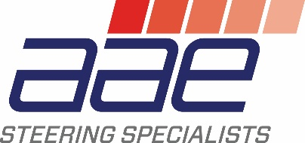
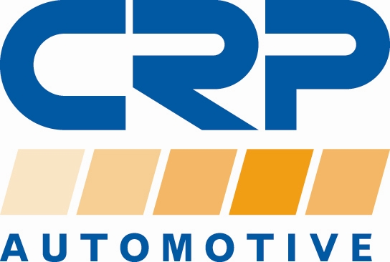

PRESS RELEASE

For additional information contact:
Monika LaPrete, Marketing Communications Director
Phone: (609) 578.4100 Fax: (609) 578.4050
E-mail: Mlaprete@crpindustries.com

AAE Remanufactured EPS Rack Restores OE Steering Performance on Audi A4 and A5 Models

- First-to-market solution, offers direct replacement and cost savings

Cranbury, NJ… CRP Automotive (crpautomotive.com), a leading source of OE-quality replacement and service parts, now offers an AAE Remanufactured Electric Power Steering (EPS) Rack (P/N ER9110) for popular Audi models. This first-to-market solution is a direct replacement for failed Audi OEM units that can help restore steering performance at a lower cost than the OE part.

Each remanufactured AAE EPS rack undergoes multiple repair and inspection checks during assembly, including a check for water ingression, a common cause of failure for the part. To ensure OE performance and durability are achieved, all the internal seals and gaskets are replaced, and new bellows and clamps are installed. A new heat shield mat is also installed to replace the worn one. Additionally, the Power Steering Control module is electronically tested to make sure no fault codes are present.

CRP Automotive offers AAE Remanufactured EPS Rack replacement on Audi A4, A4 Quattro, A5, A5 Quattro, Allroad, RS5, S4, and S5 models from 2012-2017. Application coverage exceeds 227,000 VIO in the United States and Canada.

Jumpstart Team Sign up
Join CRP Automotive’s Jumpstart Team. It’s the best way to stay up to date with the latest information on CRP Automotive brands and products. Sign up is quick and easy, just visit: www.crpautomotive.com/jumpstart.

About the AAE Brand
CRP offers in its AAE brand a wide range of OE-quality steering system components for import and domestic vehicles. The AAE programs include EPS, HPS, and EHPS new and remanufactured parts. Every AAE part undergoes rigorous testing and quality control, leading to one of the lowest warranty rates in the industry. All AAE remanufacturing is done in the USA, ensuring that only high-quality, 100% tested components wear the AAE tag.

About CRP Automotive
CRP Automotive, a business unit of CRP Industries, is a leading name in high-quality automotive replacement parts throughout North America. Our family of brands, which includes AAE Steering System Components, REIN Replacement Parts, Pentosin Technical Fluids, and AJUSA Gaskets covers a wide range of product categories — and an even more extensive range of vehicle applications. We create sustainable solutions to problems caused by advancing technology — keeping vehicles on the road longer and stronger. To ensure we are always in touch with the current and future needs of the market, we maintain a close connection with the professional repair technicians who select and install our products in imported and domestic vehicles.

For additional information, visit: www.crpautomotive.com

Image file:
CRP-AAE-Reman-EPS-Audi.jpg

Caption:
AAE Remanufactured EPS Rack restores OE steering performance on Audi A4 and A5 models.

# # #

Media contact:
Jake Spencer
Barolin + Spencer
800-536-6222
jake.spencer@barolin-spencer.com

306-21/CP1093

