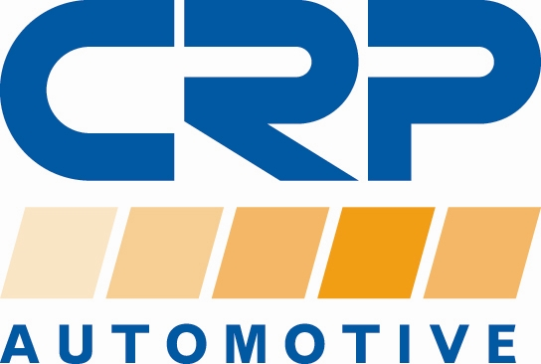

PRESS RELEASE

For additional information contact:
Monika LaPrete, Marketing Communications Director
Phone: (609) 578.4100 Fax: (609) 578.4050
E-mail: Mlaprete@crpindustries.com

CRP Automotive’s 2021 Fall Virtual Roadshow Offers Customers Two Ways to Connect for 2022 Sales and Marketing Planning

- Customers can meet in-person at AAPEX 2021 or virtual meeting online

Cranbury, NJ… CRP Automotive (crpautomotive.com), a leading source of OE-quality replacement and service parts, kicked-off another virtual roadshow outreach to meet with customers in addition to its attendance at this year’s AAPEX show. The new program, which is called, 21 JUMPSTART – Two Ways to Connect, One Way to Drive Your Sales, gives customers and industry partners the choice of a face-to-face meeting at the CRP booth during the show or a virtual meeting online.

In 2020, CRP launched its first Virtual Roadshow and initiated virtual planning sessions with its customers in response to the cancelled 2020 AAPEX show and pandemic restrictions. The virtual meetings were very successful and became a favorite meeting option with many customers.

21 JUMPSTART is starting now, and CRP’s sales force will be reaching out to customers around the country to schedule meeting sessions. This interactive forum is designed to deliver an experience similar to CRP’s AAPEX booth (# 3471), which will be showcased this November in Las Vegas. Customers will learn all about CRP Automotive's new products, training sessions, and plans for maximizing sales and marketing efforts in 2022.

Michael Palm, CRP VP of Marketing & Sales, noted, “We are very excited about our 21 Jumpstart Virtual Roadshow and want to make sure that every one of our customers has the opportunity to connect. Last year’s events were very successful and delivered exceptional results in spite of many challenges. We received great feedback from our partners and that encouraged us to continue the program going into 2022.”

Jumpstart Team Sign up
Join CRP Automotive’s Jumpstart Team. It’s the best way to stay up to date with the latest information on CRP Automotive brands and products. Sign up is quick and easy, just visit: www.crpautomotive.com/jumpstart.

About CRP Automotive
CRP Automotive, a business unit of CRP Industries, is a leading name in high-quality automotive replacement parts throughout North America. Our family of brands, which includes AAE Steering System Components, REIN Replacement Parts, Pentosin Technical Fluids, and AJUSA Gaskets covers a wide range of product categories — and an even more extensive range of vehicle applications. We create sustainable solutions to problems caused by advancing technology — keeping vehicles on the road longer and stronger. To ensure we are always in touch with the current and future needs of the market, we maintain a close connection with the professional repair technicians who select and install our products in imported and domestic vehicles.

For additional information, visit: www.crpautomotive.com

Image file:
CRP-Automotive-21JUMPSTART.jpg

Caption:
CRP Automotive’s 21 JUMPSTART Program Offers Customers the option to meet in-person at AAPEX 2021 or via the CRP Virtual Roadshow.

# # #

Media contact:
Jake Spencer
Barolin + Spencer
800-536-6222
jake.spencer@barolin-spencer.com

306-21/CP1093

